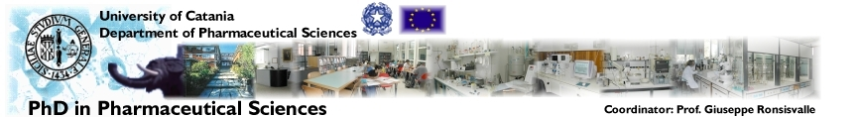
id Pharm Sc

International Doctorate in Pharmaceutical Sciences (UniCT)
Member of Paul Ehrlich MedChem European PhD Network
and
Lifelong Learning Programme (Faculty of Pharmacy)

May 2010 Seminars

  13.05.2010 |  | Introduction
  13.05.2010 | 9:00-11:00  AULA C | Integrated analytical approaches for the study of ligand-target protein interaction  Vincenza ANDRISANO  Dip. Scienze Farmaceutiche  (Università di Bologna)
  13.05.2010 |  | Incontro con i dottorandi
  20.05.2010 |  | Introduction
  20.05.2010 | 10:00-12:00  AULA C | Immunosuppressive microenvironment in transgenic mopuse melanoma model  Victor UMANSKI  German Cancer Res. Centre (Heidelberg)
  20.05.2010 |  | Incontro con I dottorandi
  27.05.2010 |  | Introduction
  27.05.2010 | 17:00-19:00  AULA C | A multidisciplinary approach to target beta-amyloid aggregation in Alzheimer’s disease  Angelo CAROTTI  Dip. Farmacochimico  (Università di Bari)
  27.05.2010 |  | Incontro con i dottorandi

Edificio 2 – Città Universitaria
Coordinator
Prof. Giuseppe Ronsisvalle

